R.Nagendra

1921214050

Java

30-08-2022

1.

import java.util.Scanner;

public class Weeks

{

public static void main(String args[])

{

int m, year, week, day;

Scanner s = new Scanner(System.in);

System.out.print("Enter the number of days:");

m = s.nextInt();

year = m / 365;

m = m % 365;

System.out.println("No. of years:"+year);

week = m / 7;

m = m % 7;

System.out.println("No. of weeks:"+week);

day = m;

System.out.println("No. of days:"+day);

}

}

**OUTPUT:**

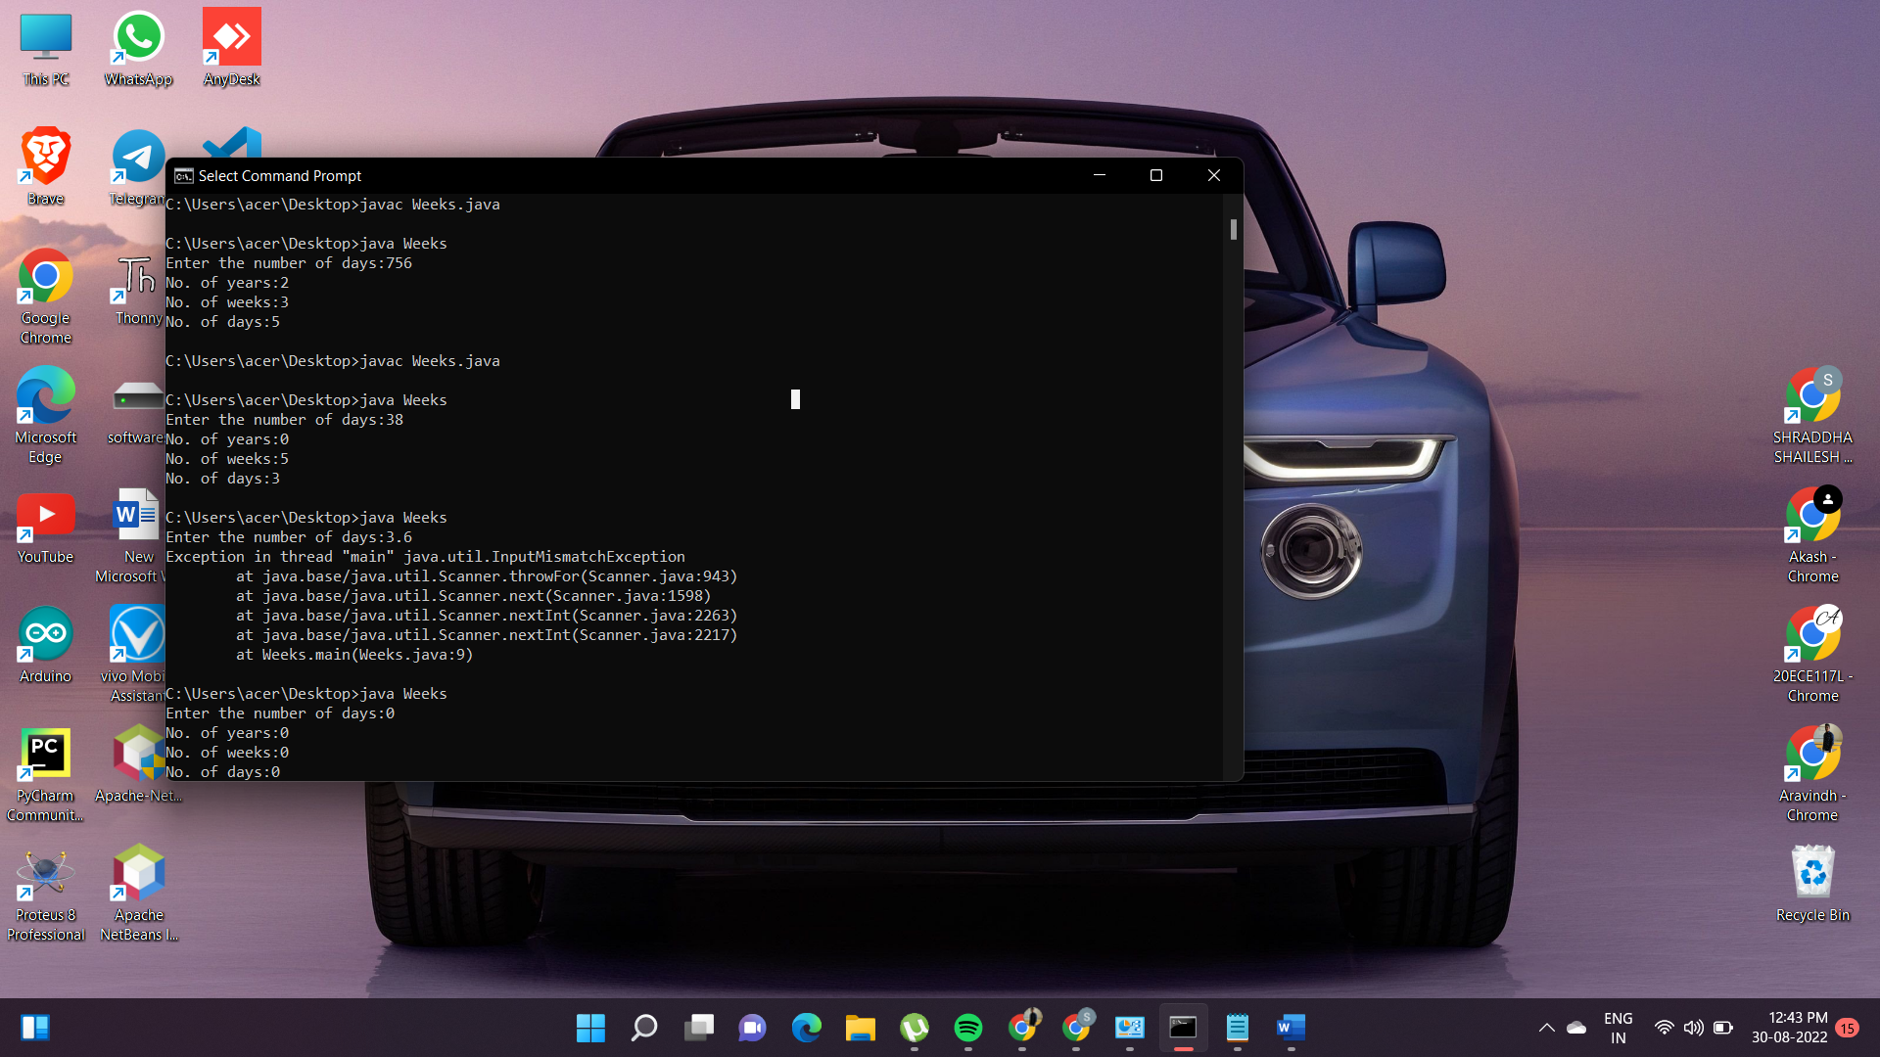

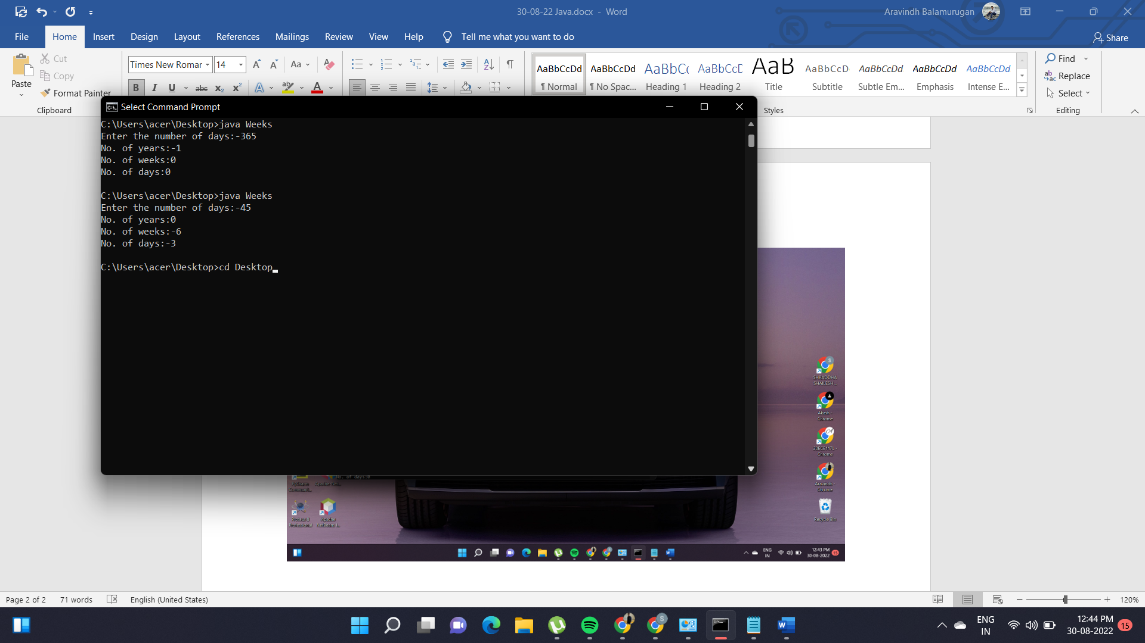

**2.**

import java.util.*;

class Main{

public static void main(String args[])

{

int i,j,m=0,flag=0,prime=0,composite=0,n,count;

Scanner s= new Scanner(System.in);

System.out.println("enter how many numbers");

count=s.nextInt();

for(j=0;j<count;j++)

{

n=s.nextInt();

m=n/2;

if(n==0||n==1){

prime=prime+1 ;

}

else

{

for(i=2;i<=m;i++)

{

if(n%i==0){

composite=composite+1 ;

flag=1;

break;

}

}

if(flag==0)

{

prime=prime+1;

}

}

}

System.out.println("number of prime:"+prime);

System.out.println("number of prime:"+composite);

}

}

**OUTPUT:**

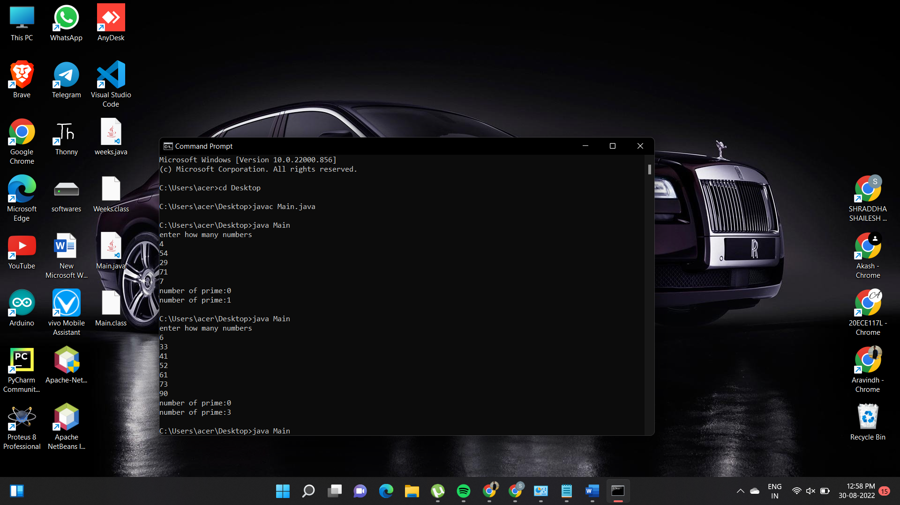

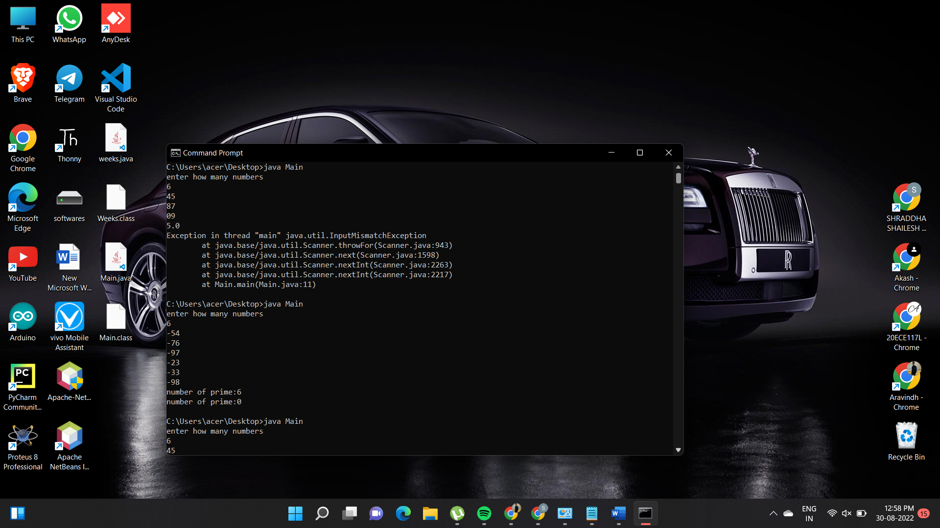

**3.**

import java.util.*;

class Main{

public static void main(String args[])

{

String s1,s2;

boolean result;

Scanner s= new Scanner(System.in);

s1=s.nextLine();

s2=s.nextLine();

result=s1.equals(s2);

if (result==false)

{

System.out.println("User name is Invalid");

}

else

{

System.out.println("User name is valid");

}

}

}

**OUTPUT:**

